Lesson 3 Demo 1: Install and Configure Metric Server

This section will guide you to:

* Install and configure metric server

This lab has one sub-section, namely:

1. Installing and configuring metric server

**Note:** If you don’t have an existing Kubernetes cluster, refer to the Demo 1.1 of Lesson 1.

**Step 1:** Installing and configuring metric server

The Kubernetes metric server is an aggregator of resource usage data in your cluster

* Start the kubernetes cluster in your lab
* Check if metric server is installed by default in your cluster using the below command  
    
  *kubectl get pods --all-namespaces | grep metrics-server*
* If this command doesn’t return anything, we need to install a metrics server
* Run the following command to install jq:

*sudo apt install jq*

* Copy and paste the commands below and hit **Enter** to execute them.

>> *DOWNLOAD_URL=$(curl --silent "https://api.github.com/repos/kubernetes-sigs/metrics-server/releases/20705532" | jq -r .tarball_url)*

*>> DOWNLOAD_VERSION=$(grep -o '[^/v]*$' <<< $DOWNLOAD_URL)*

*>> curl -Ls $DOWNLOAD_URL -o metrics-server-$DOWNLOAD_VERSION.tar.gz*

*>> mkdir metrics-server-$DOWNLOAD_VERSION*

*>> tar -xzf metrics-server-$DOWNLOAD_VERSION.tar.gz --directory metrics-server-$DOWNLOAD_VERSION --strip-components 1*

*>> kubectl apply -f metrics-server-$DOWNLOAD_VERSION/deploy/1.8+/*

* Extract it and apply the version 1.8+ manifests to your cluster as shown below:

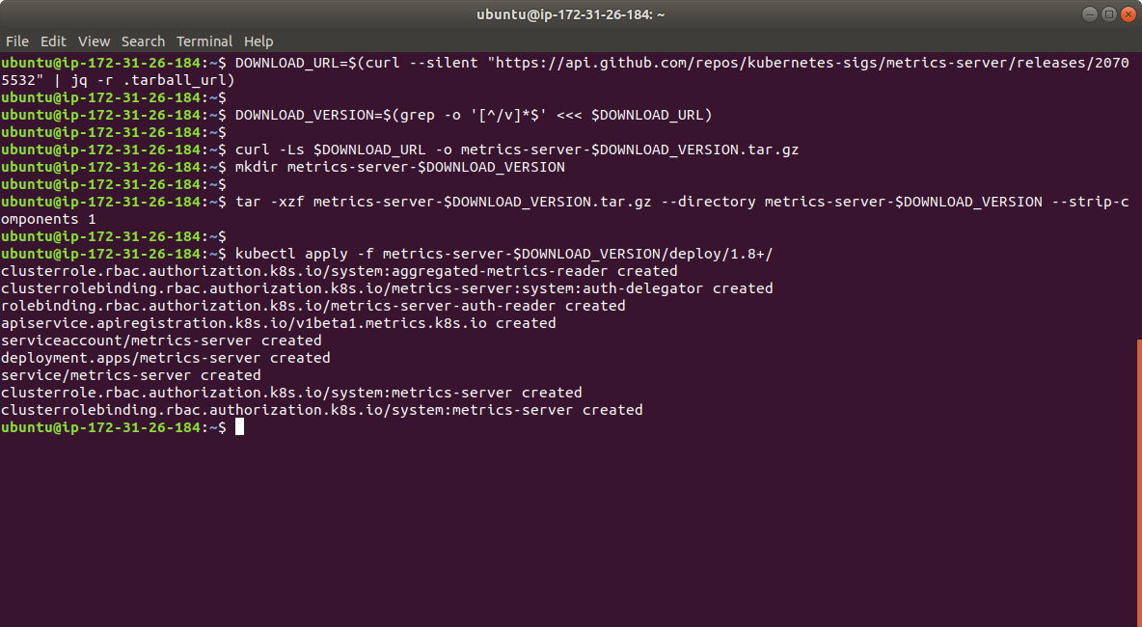

* Verify that the metric server deployment is running the desired number of pods with the following command:

*kubectl get deployment metrics-server -n kube-system*

